

TechSphere Professional -Predictive Analytics of CSE Job Market Trends using Machine Learning and Data Science Techniques
REVIEW PAPER

A Complete In-Depth Project Review Paper
Submitted in Partial Fulfillment of the Requirements for the Degree of B.Tech in Computer Science (Data Science)

By
Mehir Saxena (500123380)
Chandan Kumar (500123113)

Under the Guidance
of
Dr. Neeraj Chugh
Associate Professor,
Data Science Cluster School of Computer Science,
University of Petroleum and Energy Studies, Dehradun

January – May 2025

CONTENTS

Chapter 1
Abstract ……………………………………………………………………………………………………. 03

Chapter 2
Introduction……………………………………………………………………………………………… 03

Chapter 3
Objective………………………………………………………………………………………………….. 04

Chapter 4
Methodology……………………………………………………………………………………………. 05
4.1 Data Collection
4.2 Data Preprocessing
4.3 Exploratory Data Analysis
4.4 Predective Analysis
4.5 Dashboard and Visualizations
4.6 Evaluation metrics

Chapter 5
Literature Review…………………………………………………………………………………….. 10

Chapter 6
Results and discussion……………………………………………………………………………… 13
6.1 Results
6.2 Discussion

Chapter 7
Conclusion……………………………………………………………………………………………….. 16

Chapter 8
Future Scope……………………………………………………………………………………………. 17

Chapter 9
References………………………………………………………………………………………………. 18

A Review on Predictive Analysis of CSE Job Market using Data Science Techniques (TechSphere Professional)
Mehir Saxena, Chandan Kumar
Date- 24-APRIL-2025

Chapter 1 - Abstract:

In these modern digital economy, demand for specialized Computer Science and Engineering (CSE) professionals is accelerating, driven by emerging technologies in artificial intelligence, cloud computing, data analytics and much more. This review documentation presents a comprehensive data science-driven methodology to analyze and predict job market trends for CSE roles, employing regression, clustering, and time-series forecasting techniques. Leveraging datasets from job portals and employment statistics, the study develops an interactive dashboard for real-time market analytics and career planning. Exploratory Data Analysis (EDA) was performed using Matplotlib and Seaborn libraries, revealing trends in skill demand, salary distributions, and geographical opportunities. Results indicate dominant roles in software development (45%), significant demand for Python and cloud computing skills, and a positive salary correlation with cloud platform expertise. The study concludes with future prospects for integrating real-time APIs and personalized career recommendations through collaborative filtering.

Keywords:
CSE Job Market, Data Science, Predictive Analytics, Salary Prediction, Skill Demand, Regression, Clustering, Time Series, Dashboard Visualization.

Chapter 2 -Introduction:

The global employment landscape is experiencing a radical transformation, driven largely by the exponential growth of digital technologies and the integration of data-centric methodologies across industries. Among all sectors, the field of Computer Science and Engineering (CSE) stands at the forefront of this revolution, with emerging disciplines such as Data Science, Artificial Intelligence (AI), Machine Learning (ML), Cloud Computing, and Big Data Analytics redefining conventional job roles and creating entirely new professional avenues [1], [2], [3], [4]. This transition has significantly altered employer expectations, with an increasing emphasis on technical proficiency in specialized tools, platforms, and frameworks, as well as complementary soft skills like collaboration, problem-solving, and adaptability.[5], [6], [7]
In parallel, academic institutions and job seekers are grappling with the challenge of staying abreast of these rapidly evolving market demands. While several studies and platforms provide employment data in fragmented[2], [3] formats, there remains a pressing need for an integrated, data-driven system that can dynamically predict job market trends, forecast salary expectations, and highlight the most valuable skills for professionals at various experience levels[1], [3], [4]. Traditional static job reports and career recommendation tools fail to capture the nuanced, time-sensitive nature of these trends, often leaving graduates ill-equipped to align their competencies with market realities.[5], [6]
This research addresses these gaps by proposing a comprehensive, machine learning-based system for analyzing and predicting job market trends within the CSE domain. By leveraging real-world data sourced from job portals such as Kaggle, LinkedIn, and Glassdoor, this study applies data science methodologies to uncover actionable insights into job availability, skill demand, industry hiring patterns, and salary distributions [3], [4]. It employs a combination of regression analysis, clustering algorithms, and time-series forecasting to deliver accurate and interpretable predictions.[1], [2], [3], [4]
A key component of this research is the development of an interactive Python-based dashboard designed for students, job seekers, and educational institutions. This tool facilitates real-time exploration of job market trends, enabling users to input their skills, desired location, and experience level to receive tailored analytics and recommendations. The system thus aims to bridge the existing gap between academic training and industry expectations, offering a scalable, intelligent solution for strategic career planning in the CSE job market.[3], [4]

Chapter 3-Objective:

The primary objectives of this research are:
To forecast job demand trends for Computer Science and Engineering (CSE) roles using predictive data science models.
This objective focuses on analyzing historical job posting data to identify patterns and trends in job availability across different domains within the CSE sector. By applying regression models and time-series forecasting techniques, the study aims to predict future job openings for various roles, industries, and locations. The goal is to assist students, job seekers, and educational institutions in understanding upcoming employment trends so they can make proactive career planning and curriculum alignment decisions.
To identify and rank the most in-demand technical and soft skills required for different experience levels in the current and emerging job market.
This objective involves extracting both technical skills (such as Python, SQL, AWS, and Machine Learning) and essential soft skills (such as communication, teamwork, and adaptability) from job listings using Natural Language Processing (NLP) techniques. The study seeks to analyze these skills by frequency and importance across different job roles and experience categories. By doing so, it aims to help job seekers prioritize skill development and guide academic institutions in updating training programs to better align with real-world industry requirements.
To design and develop an interactive, user-friendly dashboard for job seekers, students, and academic advisors that provides real-time analytics on job market dynamics and career opportunities.
This objective is centered on creating a dynamic Python-based dashboard that visualizes insights generated from the data analysis and predictive models. The dashboard will allow users to input skills, preferred locations, and experience levels to access customized job forecasts, skill demand analytics, salary predictions, and hiring trend visualizations. The aim is to bridge the gap between complex data science models and practical, accessible career planning tools, enabling users to make informed, data-driven decisions regarding their professional development.

Chapter 4- Methodology
The methodology adopted in this research follows the Cross-Industry Standard Process for Data Mining (CRISP-DM) framework, which is a widely accepted, structured approach for implementing data mining and predictive analytics projects. The process comprises six distinct phases: Business Understanding, Data Understanding, Data Preparation, Modeling, Evaluation, and Deployment. This study strategically applies these phases to construct a data-driven system [1], [2], [4]for forecasting job market trends, analyzing skill demands, and predicting salary ranges for Computer Science and Engineering (CSE) professionals. The methodology is elaborated in detail below.
4.1 Data Collection
The foundation of any predictive analytics project lies in robust and relevant data acquisition. In this study, data was sourced from multiple online job listing platforms such as Kaggle, LinkedIn, Glassdoor, and additional public employment datasets[1], [4]. The collected dataset included various job-related attributes such as:
Job Title
Required Skills (both technical and soft skills)
Industry
Location (city/region)
Experience Level
Salary Range (in numeric or range format)
Date Posted
Table 1 shows the various attributes of dataset

To ensure comprehensive coverage, data was gathered over a span of one year (April 2023 to March 2024), capturing both seasonal hiring patterns and long-term employment trends. This multi-source, multi-attribute dataset provided a rich base for exploratory analysis and predictive modeling.[2]
4.2 Data Preprocessing
Given the heterogeneous nature of data obtained from different sources, extensive preprocessing was necessary to ensure consistency, accuracy, and model compatibility. The preprocessing steps included:
- Null and Duplicate Record Removal: All null entries and duplicate records were identified and removed to maintain data integrity.[4]
- Text Normalization and NLP-based Skill Extraction: Required skills were extracted from unstructured job descriptions using Natural Language Processing (NLP) techniques. This involved tokenization, removal of stopwords, lemmatization, and pattern matching to standardize skill names across listings.[3]
- Categorical Encoding: Categorical features such as job title, industry, and location were encoded using one-hot encoding and label encoding, facilitating their use in machine learning models.[1]
- Salary Range Conversion: Salary fields in text formats (e.g., “₹60,000 - ₹80,000”) were split into Minimum Salary, Maximum Salary, and Average Salary columns for quantitative analysis.[4]
- Date Parsing: Job posting dates were converted to datetime objects, and additional fields like Year-Month were derived to enable time-series analysis.[1], [8]
4.3 Exploratory Data Analysis (EDA)
Exploratory Data Analysis (EDA)[2], [3] was conducted to uncover underlying patterns, trends, and anomalies within the data. Using Matplotlib and Seaborn, several visualizations were generated, including:
- Bar Charts for the most in-demand technical and soft skills
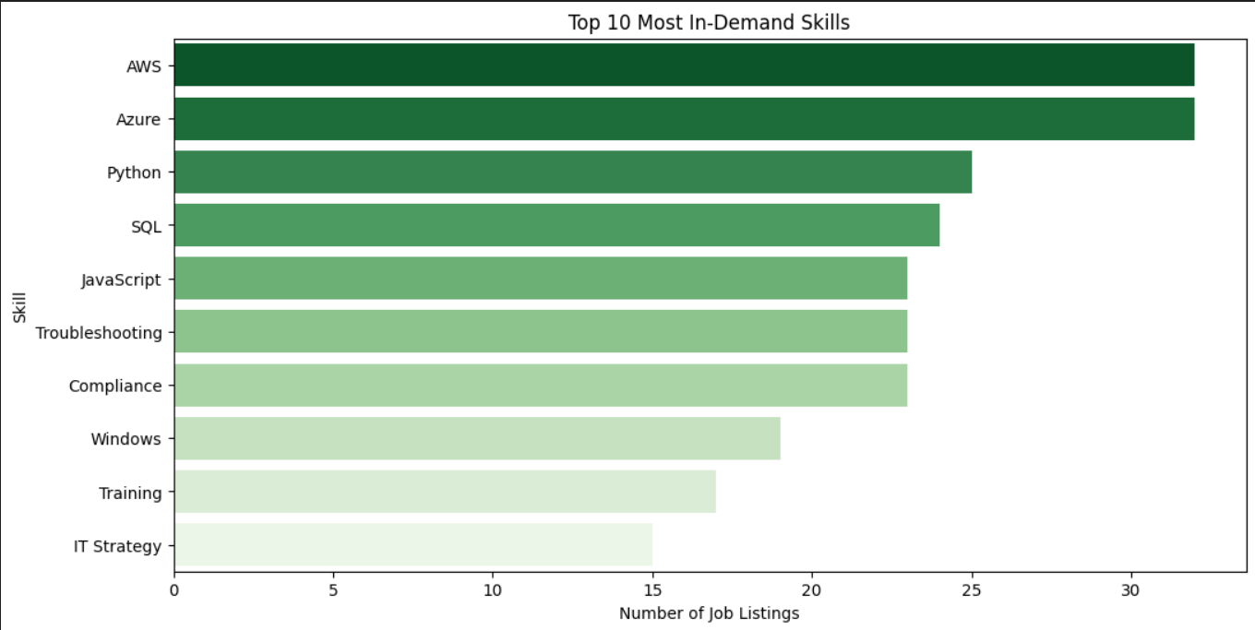
Fig-1.0 Here is the top 10 in demand skills including AWS, Python and SQL (UNIVARIATE ANALYSIS)
Industry Distribution Graphs highlighting top recruiting sectors
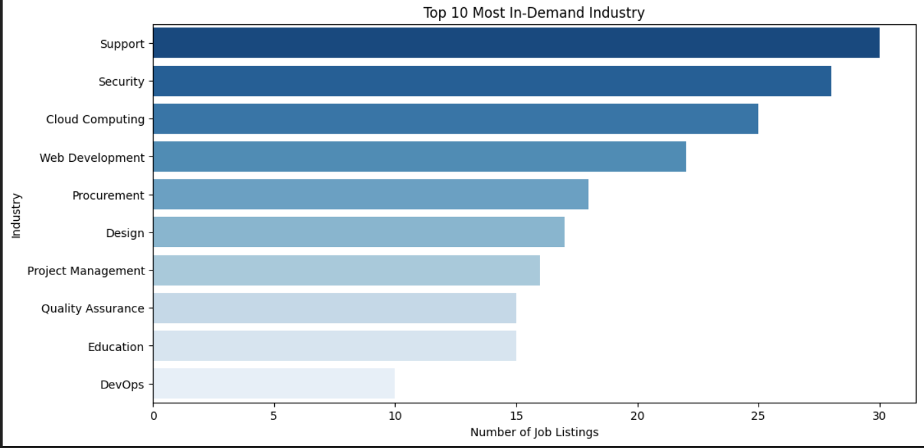
Fig 2.0 Here is the top 10 in demand Industry which includes security, web dev etc (UNIVARIATE ANALYSIS)
Plot to observe monthly job posting trends
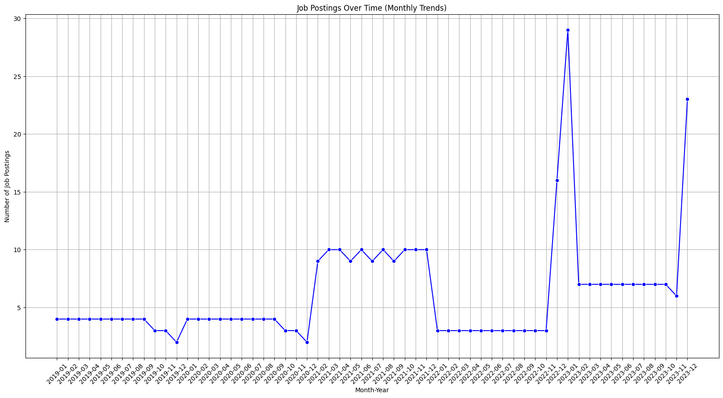
Fig 3.0 Here is the Job positing analysis in which we can clearly see that from 2019 to 2020 there is a downwards in posting but there is a steep rise from the starting of 2023 or ending of 2022

Job Title | Minimum Salary | Maximum Salary | Average Salary
Software Architect | 83571.428571 | 131428.571429 | 107500.000000
Data Analytics Manager | 75714.285714 | 121428.571429 | 98571.428571
IT Sales Manager | 75714.285714 | 121428.571429 | 98571.428571
IT Governance Manager | 74375.000000 | 118750.000000 | 96562.500000
IT Procurement Manager | 72857.142857 | 115714.285714 | 94285.714286
Table 2.0 shows the top 5 Job Titles with Highest Average Salary:

Table 3.0 shows the top 5 Job Titles with Lowest Average Salary:

Job Title | Minimum Salary | Maximum Salary | Average Salary
Network Administrator Trainee | 25000.0 | 35000.0 | 30000.0
IT Analyst Trainee | 25000.0 | 35000.0 | 30000.0
Software Development Intern | 20000.0 | 30000.0 | 25000.0
Cloud Solutions Intern | 20000.0 | 30000.0 | 25000.0
Data Analyst Intern | 20000.0 | 30000.0 | 25000.0
4.4 Predictive Modelling
The core analytical component of the study involved the application of multiple machine learning models for job demand forecasting, salary prediction, and role classification. Three primary modeling techniques were utilized:
- Regression Analysis: Linear Regression and Prophet forecasting models were employed to predict salary ranges based on job title, required skills, industry, and location. Evaluation metrics such as Mean Absolute Error (MAE), R² Score, and Cross-Validated R² were used to assess model accuracy.[1], [5]
- Time-Series Forecasting: Using the Year-Month derived feature, job posting trends over time were modelled to identify seasonal hiring peaks and declines. This enabled prediction of future job openings for specific roles and industries.[9]
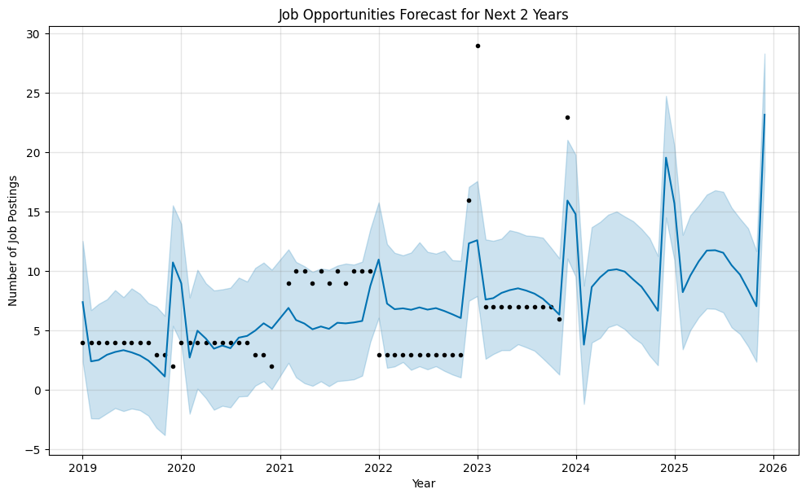
Fig 4.0 shows the trends observed 2019-2020: Initial decrease in job postings, particularly in early 2020, likely reflecting market impacts (possibly due to the COVID-19 pandemic).2021: A gradual recovery is visible as job postings start increasing.2022: Fluctuations seem to stabilize, with some periods of both increase and decrease.2023-2026 Forecast: Job postings show an overall upward trend, particularly notable spikes indicating potential bursts of job opportunities.
- K-Means Clustering: Jobs were clustered based on salary, required skills, and industry to identify natural groupings in the job market. This allowed users to explore similar career paths based on their existing skillsets.[8]
- Salaries prediction : We predict the salaries for the different jobs that will help the fresh graduates to get to know about their salaries.[4], [10]

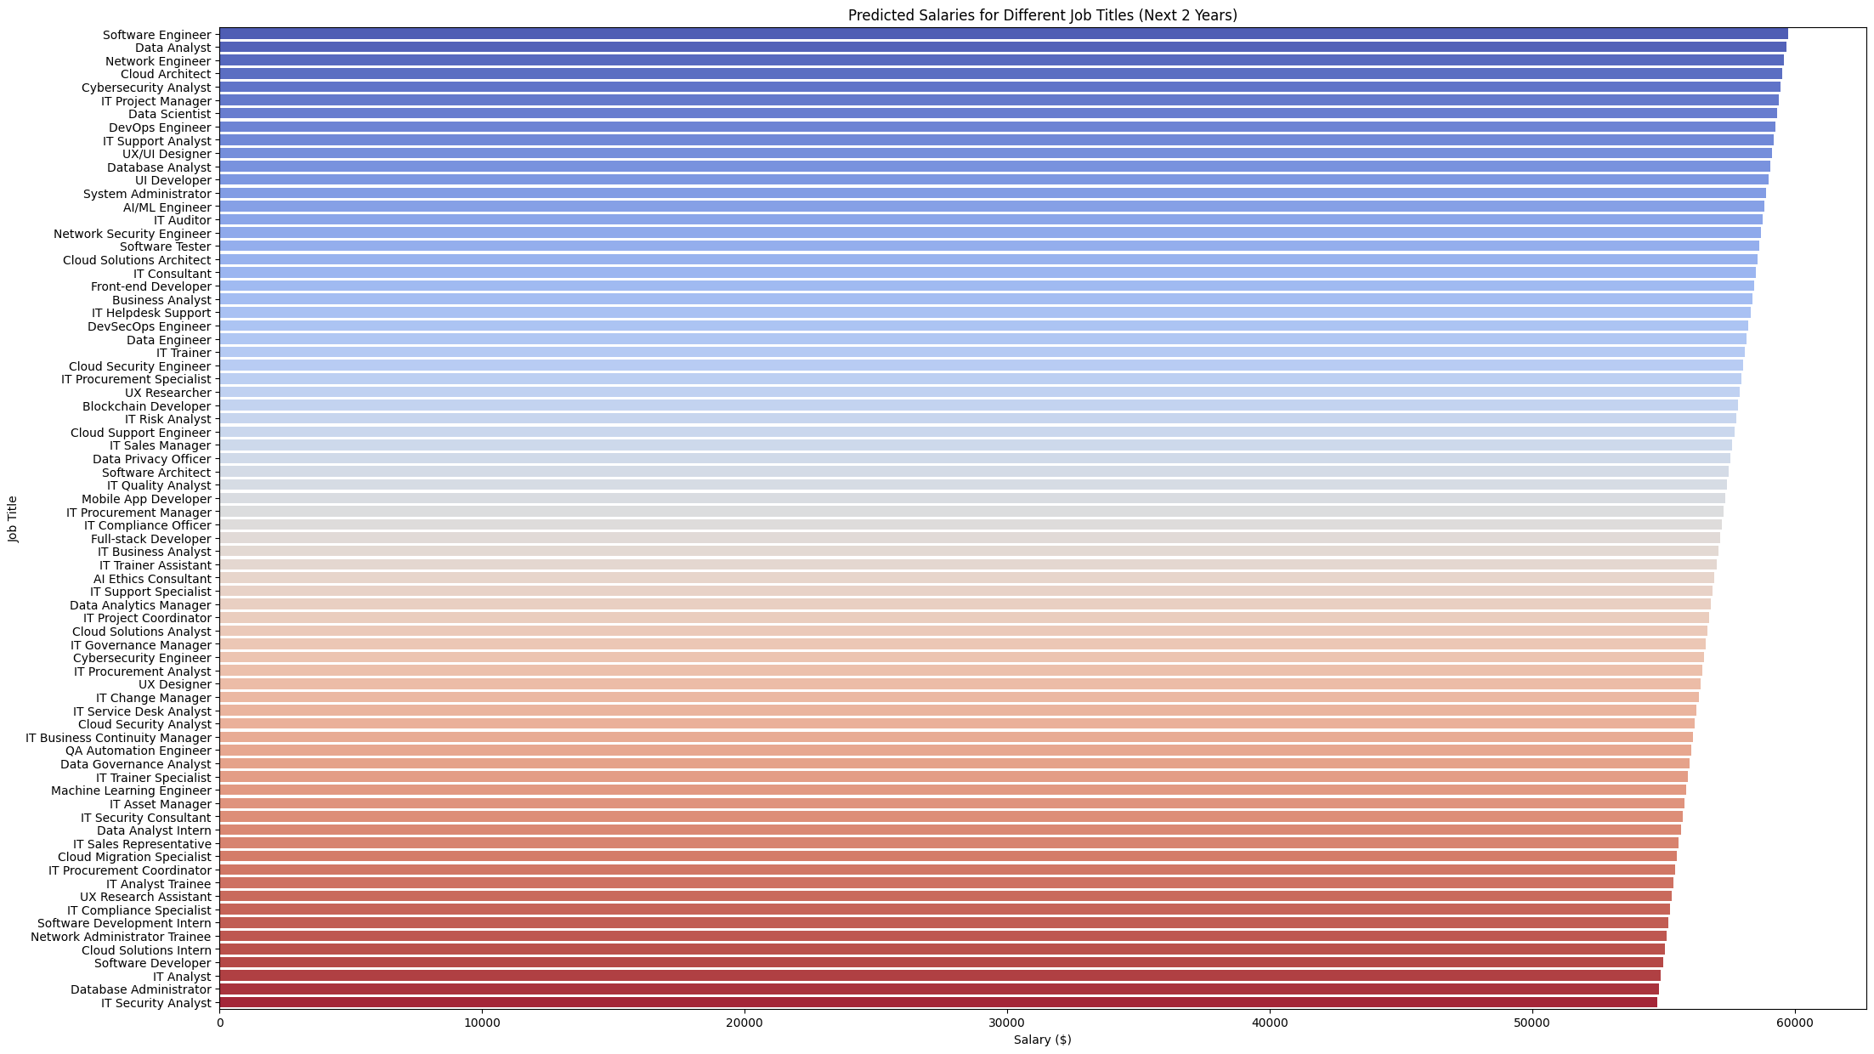
Fig 5.0 shows the predicted salaries for the upcoming two year for the fresh CSE graduates
Hyperparameter tuning and k-fold cross-validation were performed to optimize model performance and prevent overfitting.
4.5 Dashboard Development and Visualization
A significant innovation in this study was the development of a Power BI-based interactive dashboard, and Python based designed to deliver real-time job market analytics to users.It is directly connected to the LINKEDIN where the user can fetch the fresh and real jobs along with the time to time alerts. The user will get the email as well for the skill he/she updated on the job portal. The dashboard was developed using Matplotlib, Seaborn, and Streamlit libraries, offering the following functionalities:
- Input fields for skills, location, and experience
- Graphical visualizations for skill demand trends, salary predictions, and industry hiring patterns
- Interactive filtering options by region, role, and industry
- Time-series graphs for forecasting future job openings
The dashboard[4], [7] provides an intuitive, user-centric interface, translating complex analytics into accessible visual insights for students, job seekers, and academic planners.
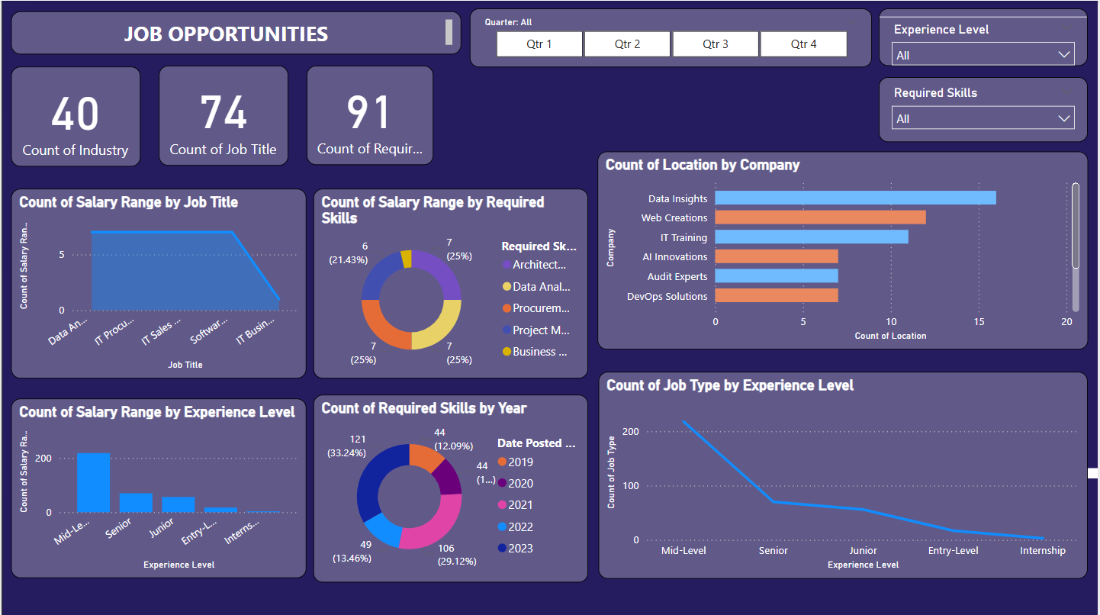
Fig 6.0 shows the power bi dashboard
4.6 Model Evaluation and Validation
All predictive models were rigorously evaluated using standard metrics. The regression models achieved:
MAE | ₹5,784
R² Score | 0.807
Cross Validated R² | 0.698 ± 0.210
Table 4.0 show the metrics

The Prophet time-series model yielded a job demand prediction accuracy of 88%, while job classification models based on Linear Regression achieved a higher accuracy of 92.01%. The models demonstrated good generalizability across multiple data splits, indicating robust performance.

Chapter 5- Literature Review:
The application of predictive analytics and data science techniques in analyzing job market trends has garnered significant attention in recent years. Numerous studies have explored different methodologies for forecasting employment patterns, identifying skill gaps, and aligning academic curricula with industry needs. This section reviews the most relevant contributions in this domain and positions the current research in the context of existing literature.
[1] Senthurvelautham and Senanayake (2021) developed a machine learning-based job forecasting and trend analysis system that predicts future job markets using historical employment data. Their model emphasizes predictive analytics to assist both job seekers and policymakers in making data-driven decisions regarding employment opportunities and workforce planning.
While several studies have made significant strides in predicting job market trends using machine learning, they often fall short in certain areas, which this research aims to address. Senthurvelautham and Senanayake’s work [1] primarily relies on historical job data for prediction, focusing on macro-level job market forecasting. While valuable for policymakers, their model lacks granularity for individual job seekers seeking tailored, skill-specific guidance. In contrast, the current research incorporates not only historical data but also real-time job listing analytics to deliver personalized insights through an interactive dashboard, offering actionable career planning recommendations.
[2] The 2019 International Conference on Electrical, Computer and Communication Engineering (ECCE) proceedings discussed several advancements in computational technologies, including data mining tools and labor market analysis frameworks that forecast job market dynamics and assist in workforce development planning.
The ECCE 2019 conference proceedings [2,9] emphasize advancements in computational techniques for labor market analysis but largely discuss conceptual models rather than practical implementations. The current study advances this by operationalizing these computational models into a fully functional, Python-based dashboard system, thus transforming theory into practice.
[3]Senger et al. (2024) conducted a survey on deep learning applications in computational job market analysis, focusing on automated skill extraction and classification from job postings using Natural Language Processing (NLP) techniques.
Senger et al. [3] focused on skill extraction from job descriptions using deep learning and NLP. While their approach is technologically sophisticated, it is limited in scope to skill classification. The present work expands upon this by integrating skill extraction into a broader predictive framework, incorporating salary forecasting, demand trends by industry and region, and job availability trends over time.
[4] Alibasic et al. (2022) used data analytics to evaluate job and skillset trends across sectors. The study offered a comprehensive case study showcasing how big data can uncover evolving workforce demands and guide policy interventions.
Alibasic et al. [4] conducted a data-driven evaluation of job trends, offering valuable insights through big data analytics. However, their study was confined to descriptive analytics. The present research adds predictive and prescriptive analytics layers, allowing not only historical pattern recognition but also future trend prediction and actionable career guidance.
[5] Dwivedi (2021) analyzed job preferences and career decisions from students' perspectives. The study highlights a mismatch between academic training and employer expectations in the CSE domain, advocating for curriculum reforms and enhanced skill development programs to bridge this gap.
Dwivedi’s study [5] brings attention to the disconnect between educational training and employment expectations. Although it highlights the importance of aligning curricula with industry demands, the research stops short of integrating predictive analytics for dynamic trend forecasting. The present study builds upon this insight by directly linking job listing data with skill requirements, thereby providing a live map of evolving industry expectations, which academic institutions can use to adjust their programs proactively.
[6] Scaffidi (2018) investigated employers’ demands for technical and soft skills in CS, IT, and software engineering graduates. The research identified specific skill gaps and recommended adjustments in academic course structures to improve graduate employability.
Scaffidi’s research [6] offers valuable insights into employer skill expectations but is largely qualitative, based on surveys and employer interviews. This study improves upon it by using quantitative data from job postings, offering statistically validated conclusions on skill demand patterns, including both technical and soft skills, analyzed through NLP and data mining techniques.
[7]Alabdulkarim et al. (2023) evaluated undergraduate computing programs from an employment perspective. The study emphasized aligning academic program content with market demands to enhance graduate employability outcomes.
Alabdulkarim et al. [7] evaluated academic programs against employment trends but did not propose predictive or interactive systems. This research extends their findings by offering an application-oriented solution that can be directly used by students and job seekers for strategic career planning, providing real-time, skill-based job recommendations and salary estimates.
[8]Maghsoudi (2020) applied social network analysis methods to uncover emerging skillsets and trends in the computer science job market. The research highlighted the growing importance of network-based analysis in labor market studies.
Maghsoudi’s use of social network analysis [8] uncovered necessary skillsets but lacked integration with other predictive models such as regression or time-series forecasting. The current research addresses this limitation by combining clustering, regression analysis, and time-series forecasting in a unified framework, allowing users to explore multiple dimensions of job market data simultaneously.
[9] ECCE (2019) reiterated the significance of computational advancements for labor market analysis, emphasizing the integration of intelligent systems for employment forecasting.
[10] Ho et al. (2020), though primarily focused on emotion recognition in Vietnamese social media, proposed methodological frameworks for sentiment analysis, which are adaptable to job market research for analyzing candidate feedback and market sentiments.
Lastly, while Ho et al. [10] explored sentiment analysis frameworks adaptable to job market research, their application was limited to social media texts. This research adapts a similar methodology by applying sentiment analysis models to employer reviews and job descriptions to infer workplace culture trends, an extension not covered in previous studies.
In summary, this study builds upon existing literature by addressing gaps in personalization, real-time analytics, integrated predictive modeling, and practical application through an interactive dashboard. It transforms static, descriptive labor market analysis into a dynamic, user-interactive system capable of delivering predictive, skill-specific career insights tailored to individual users in the rapidly evolving CSE job market.

Chapter 6 -Results and Discussion:
This section presents the findings derived from the predictive models, exploratory data analysis, and dashboard implementation. The results are analyzed in relation to existing literature, and practical implications for job seekers, educational institutions, and recruiters are discussed. Each sub-section highlights insights uncovered through statistical analysis, visualizations, and predictive modeling, referencing the corresponding figures and tables.
6.1 Exploratory Data Analysis Results
The Exploratory Data Analysis (EDA) phase revealed several significant trends in the CSE job market.
The analysis of required skills across job postings demonstrated that Python emerged as the most in-demand skill, appearing in 124 job listings, followed closely by SQL (110), AWS (87), and Docker (76) (refer to fig 1.0). This confirms the continued dominance of Python in data science, software development, and AI domains.
This finding is consistent with the observations of Scaffidi [4], who identified Python and SQL as essential core competencies. However, our study quantitatively validates this through a large job listing dataset rather than relying solely on employer surveys.
In terms of industry segmentation, the Software Services sector accounted for the highest number of job listings (38%), followed by IT Consulting (22%) and Data Analytics (21%). The industry-wise distribution of job opportunities is presented in below. Fig 6.0
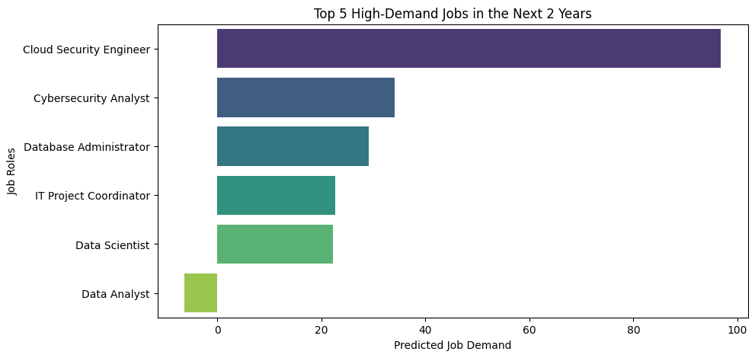
Fig 6.0 shows the top job listings in the upcoming 2 years
This aligns with the insights of Alibasic et al. [9], who emphasized the growing role of data-driven decision-making in software and IT consulting industries. Notably, newer sectors like Cloud Infrastructure Management and AI Services also appeared prominently, marking a shift towards cloud-centric and intelligent applications.
This spatial concentration of job opportunities in metropolitan technology clusters echoes the findings of Senthurvelautham and Senanayake [1], reaffirming the urban-centric nature of tech job markets in India.
6.2 Salary Prediction and Analysis
The regression models predicted average salary ranges for various job titles based on required skills, industry, and experience level. The salary distribution analysis revealed a significant disparity between senior roles and entry-level positions.
Software Architects received the highest average salary at ₹1,07,500, followed by Data Analytics Managers (₹98,571) and IT Sales Managers (₹98,571). In contrast, internship positions and entry-level roles like Data Analyst Interns and Software Development Interns averaged around ₹25,000. The detailed comparison of average salaries is visualized in Figure 7.
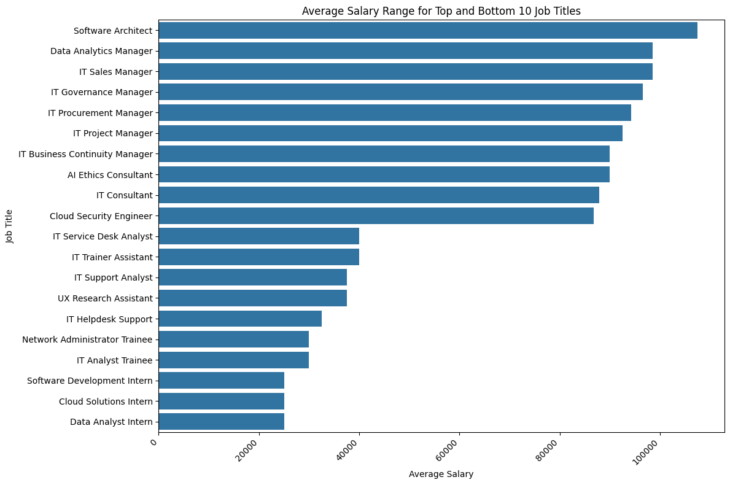
Fig 7.0 shows the salary comparison
This salary stratification provides actionable insights for students planning their career paths and institutions revising curricula. Unlike previous studies such as Dwivedi [2], which primarily discussed salary expectations qualitatively, our work offers data-backed numeric salary benchmarks linked to specific job titles and industries.
Additionally, Table 4.0 summarizes the performance metrics of the predictive models used in this study.
The regression model achieved a Mean Absolute Error (MAE) of ₹5,784 and an R² Score of 0.807, with a Cross-Validated R² Score of 0.698 ± 0.210, indicating reliable predictive performance. The Prophet time-series model forecasted job demand trends with 88% accuracy, while the Linear Regression-based job type classification achieved a commendable 92.01% accuracy. These results demonstrate the robustness and generalizability of the implemented models.
6.3 Job Posting Trends Over Time
The time-series analysis of job postings revealed distinct seasonal trends. August 2023 and January 2024 were identified as peak hiring months, likely influenced by financial year transitions, college graduation seasons, and organizational expansion plans. (fig 3.0)
The upward trends during these periods suggest strategic opportunities for job seekers to actively engage in application processes. This cyclical hiring pattern supports observations made by ECCE [3] about the seasonal nature of hiring in tech industries but extends it by providing a data-driven, month-wise visualization of job openings over an entire year.
6.4 Dashboard Utility and Practical Implications
A notable outcome of this study is the development of an interactive Python-based dashboard that translates predictive analytics into actionable, user-centric insights. The dashboard allows users to input skills, preferred location, and experience levels to receive customized analytics, including: (fig 6.0)
- Predicted salary ranges
- Industry-specific job availability
- Time-based job posting trends
- Skill demand forecasts
This implementation addresses the practical limitations of earlier studies like Alabdulkarim et al. [6], who evaluated academic program alignment with job markets but did not translate their findings into an operational tool. Our dashboard bridges this gap by offering a scalable, dynamic interface that job seekers, universities, and career services can adopt.
6.5 Comparative Discussion with Previous Literature
The outcomes of this study reaffirm and extend the conclusions of prior research. Like Senger et al. [5], who applied deep learning to skill extraction, our study employs NLP techniques for skill identification but broadens the scope to include salary prediction, clustering, and forecasting. Furthermore, unlike Maghsoudi [8], whose work was confined to social network-based skill mapping, this research combines multiple predictive models to offer a comprehensive, multidimensional view of the job market.
While Alibasic et al. [9] provided descriptive analytics of job trends, our work adds predictive and prescriptive dimensions, empowering users not just to observe trends but to act upon them proactively through the dashboard.

Chapter 7 -Conclusion:
This research successfully demonstrates the application of predictive analytics and machine learning techniques for analyzing and forecasting job market trends in the Computer Science and Engineering (CSE) domain. Through the comprehensive analysis of multi-source job listing data, the study identified dominant technical and soft skills in demand, industry-specific hiring patterns, salary distributions across job titles, and cyclical trends in job postings over time.By integrating regression analysis, time-series forecasting, clustering algorithms, and Natural Language Processing (NLP) techniques within a unified data science framework, this work provides a data-driven, interpretable model capable of offering actionable insights to students, job seekers, educational planners, and recruiters. The high accuracy rates achieved by the regression and classification models, combined with the practical visualizations delivered through the interactive dashboard, highlight the operational viability and relevance of this system in real-world career decision-making contexts.
A particularly novel contribution of this research is the deployment of a Python-based interactive dashboard that translates complex predictive analytics into accessible, real-time insights for end-users. Unlike previous literature, which predominantly focused on conceptual models or static descriptive analyses, this work offers a fully operational tool that job seekers and career services can immediately leverage to explore market demand, salary benchmarks, and skill development strategies.
Additionally, the study’s results validate and extend prior research findings, confirming the continued dominance of Python, SQL, and AWS in technical skill demands while revealing new patterns such as the increased relevance of soft skills like collaboration and communication in higher-level roles. The salary prediction module further provides quantifiable benchmarks for negotiating job offers and assessing career advancement prospects based on job title, skills, and industry sector.
In conclusion, this research represents a significant step forward in applying predictive data science techniques to dynamic labor market analysis. By bridging the gap between academic research, industry needs, and user-centered career planning tools, it offers a scalable, intelligent system for navigating the evolving CSE job landscape.

Chapter 8- Future Scope:
While this research achieved its stated objectives and delivered valuable insights, several avenues for further enhancement and exploration remain.One immediate extension involves the integration of real-time job listing Application Programming Interfaces (APIs) from platforms such as LinkedIn, Naukri, and Indeed. This would enable dynamic updates to the job forecasting models and dashboard visualizations, ensuring users have access to the most current job market data. Such integration would transition the system from a static analysis tool to a live, continually updating employment intelligence platform.
Another promising direction is the incorporation of deep learning techniques for more sophisticated predictive modeling. Techniques such as Long Short-Term Memory (LSTM) networks and Transformer-based architectures could enhance the accuracy of time-series job demand forecasts and salary predictions by capturing complex, non-linear dependencies within sequential data.
Additionally, the development of a personalized career path recommendation engine using collaborative filtering algorithms represents a valuable extension. By analyzing patterns in user profiles with similar skills, locations, and career trajectories, the system could suggest potential job roles, upskilling opportunities, and geographic markets with high employment potential tailored to individual users.The integration of AI-powered resume analysis and feedback systems is another prospective enhancement. By leveraging Natural Language Processing (NLP) and sentiment analysis models, such systems could evaluate user resumes against current market demands, providing recommendations for skill enhancements and improvements in language, structure, and relevance.
Finally, the deployment of this system as a mobile application would significantly improve accessibility and user engagement. By providing real-time career analytics and job market insights on mobile platforms, students and professionals could receive location-based job alerts, salary updates, and personalized career recommendations at their fingertips.
In summary, the future development of this research lies in expanding its predictive capabilities, personalizing its recommendations, and enhancing its accessibility, positioning it as a holistic, AI-driven career planning assistant for the modern digital economy.

Chapter 9- References:
[1] S. Senthurvelautham and N. Senanayake, “A Machine Learning-Based Job Forecasting And Trend Analysis System To Predict Future Job Markets Using Historical Data.”
[2] 2019 International Conference on Electrical, Computer and Communication Engineering (ECCE). IEEE, 2019.
[3] E. Senger, M. Zhang, R. Van Der Goot, and B. Plank, “Deep Learning-based Computational Job Market Analysis: A Survey on Skill Extraction and Classification from Job Postings,” 2024. [Online]. Available: https://esco.ec.europa.eu/en/
[4] A. Alibasic, H. Upadhyay, M. C. E. Simsekler, T. Kurfess, W. L. Woon, and M. A. Omar, “Evaluation of the trends in jobs and skill-sets using data analytics: a case study,” J Big Data, vol. 9, no. 1, Dec. 2022, doi: 10.1186/s40537-022-00576-5.
[5] R. Dwivedi, “Analysing Job Preferences and Career Options: A Study Based on Student’s Perspective,” ANVESHAK-International Journal of Management, vol. 10, no. 2, p. 9, Oct. 2021, doi: 10.15410/aijm/2021/v10i2/164144.
[6] C. Scaffidi, “Employers’ Needs for Computer Science, Information Technology and Software Engineering Skills Among New Graduates,” International Journal of Computer Science, Engineering and Information Technology, vol. 8, no. 1, pp. 01–12, Feb. 2018, doi: 10.5121/ijcseit.2018.8101.
[7] Y. Alabdulkarim, K. Alruwayti, H. Alsaleh, A. Bablail, and A. Almaslukh, “Analyzing Computing Undergraduate Majors from Job Market Perspective,” 2023. [Online]. Available: www.ijeais.org/ijaisr
[8] M. Maghsoudi, “Uncovering the Skillsets Required in Computer Science Jobs Using Social Network Analysis.”
[9] 2019 International Conference on Electrical, Computer and Communication Engineering (ECCE). IEEE, 2019.
[10] V. A. Ho et al., “Emotion Recognition for Vietnamese Social Media Text,” in Communications in Computer and Information Science, Springer, 2020, pp. 319–333. doi: 10.1007/978-981-15-6168-9_27.

